

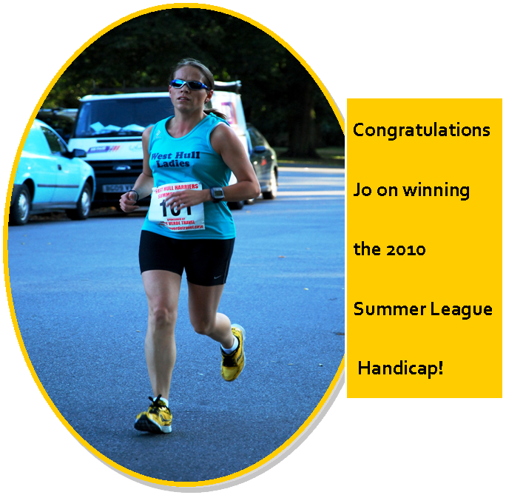

West Hull Ladies RRC Committee Meeting

Monday 2nd August 2010
Secretary: Louise Ede

Attendees: Rebecca King, Jo Townsend, Victoria Voase, Annette Pearson, Geri Wright and Louise Ede
Apologies: Karen S, Amanda Dean & Amanda Currie

- Website
AmandaD had wanted to know whether AmandaC could be willing to update the website with the newsletter each month.

- Training Officer Role and Training Officers
It was discussed assisting AmandaD with the Training Officer role given this is something which does take up a substantial amount of time. It was discussed the possibility of a system similar to our Friday ‘Buddy’ system where someone will agree to run the training on a particular Monday. It was agreed that we would also enquire with AmandaD regarding which parts of her role she would wish assistance with. It is a possibility that one of those ladies with access to the Hotmail account could be responsible for collating and sending out a training e-mail for one week at a time. It was agreed that the Training Officer Report for the newsletter can be stopped unless there is something specific that AmandaD wishes to include one particular month.

- Circulation of information for Charity Places
It was agreed that this information would not be circulated to the ladies. It was felt that if someone was seriously interested in running a marathon for charity then they are likely to make the effort to locate the information themselves.

- Club Clothing
Geri had attended with a sample of the jackets with our WHL logo. These jackets were tried on by the attendees. The jackets sizes were large and therefore it was felt that sizes XS and S would fit all the ladies at the Club, apart from our more petite ladies who will likely require a junior size. Geri will make some enquiries about a junior size, possibly aged 13-14. The jackets will be £32.00 each and the money for the jackets will be required up front.

- Any Other Business
It was felt that the Notice Board should be updated and it was agreed by Louise, Rebecca and Jo that they would attend the Club early one Friday to deal with this. A WHL kids corner would also be started and Jo confirmed she would have no objections to pictures of her daughters being displayed. A price list of our Clubwear will also be included.

It was also felt that another night out for a meal should be organised and 24th September 2010 was provisionally agreed. All ladies at the meeting confirmed their interest. It was suggested that Pascos in Cottingham would be a good venue.

Next meeting Monday 6th September 2010

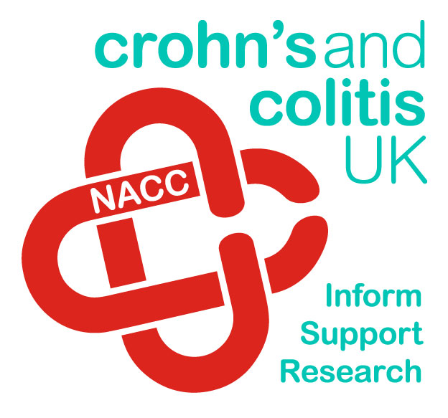
Becca’s Great North Run
Sunday 19th September 2010

Some of you may be aware that my sister has not been well. While she was in hospital recently she asked me if I would run the Great North Run and raise money for her chosen charity, Crohn’s and Colitis UK.

For those of you who don’t know, my sister is really poorly and is waiting to be put on the lung transplant list as a result of ulcerative colitis which spread to her lungs. She is only 34 years old and on oxygen at all times now. I don’t normally run for charity but couldn’t really refuse someone so ill and in hospital, so I agreed!

Crohn’s and Colitis UK support people suffering with the diseases and their families as well as funding research into new ways to treat the disease. While I have done the Great North Run a few times before I have been training really hard for this one and I am aiming to get as far under 2 hours as possible.

If you would like to sponsor me you can do so at my Just Giving web page at www.justgiving.com/rebecca-king- or if you don’t like to sponsor online let me know and you can use one of my sponsor forms.

Thank you very much for your support.

Becca xx

Muscles of the Month: Hamstrings

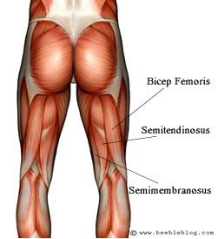
Where are they? The hamstrings are located at the posterior thigh and the tendons of these muscles form part of the tissues felt at the back of the knee. They consist of three separate muscles: semimembranosus, semitendinosus and biceps femoris. They originate from the ischial tuberosity (your sitting bone located just underneath the gluteals). Semimembranosus and semitendinosus both attach at the back of the inside knee on a bone called the tibia. Biceps femoris attaches to the other side of the knee to a bone called the fibula.

What are they? The hamstrings are knee flexors (they bend the knee). In addition, they are also hip extensors (they take the leg straight out behind us) and they rotate the lower leg when the knee is bent.

What do they do? As mentioned above, hamstrings flex the knee and extend the hip. From a running perspective, the hamstrings slow down the leg at the end of its forward swing and prevent the body (trunk) from flexing forward causing imbalance.

How do they get injured? Hamstrings injuries are fairly common, unfortunately, and once injured rehabilitation can be a long and painful process. Hamstrings can be injured through overuse, or through the quadriceps muscles (at the front of the thigh) becoming too strong and tight and causing the hamstrings to become weak. Hamstrings can also be injured through trauma (knocks, falls or blows to the muscle) or through sudden movements, which cause the muscles to stretch before they are ready. This can result in parts (or all) of the muscle or tendon tearing.
The hamstrings are a group of muscles that often become chronically tight and shortened and are amongst the main muscles that should always be stretched out after exercise. Problems with the hamstrings can cause imbalances in the gluteals and the lower back muscles, referring pain up the spine but also down into the knee.

How can hamstring problems be treated? Treatment of hamstring injuries can be prolonged and also quite painful. I treat hamstring tears through a mixture of Ultrasound and deep tissue massage. Chronically tight and shortened hamstrings are generally treated through myofascial release, Muscle Energy Techniques and facilitated stretching.

How to stretch them. There are a few really effective ways of stretching out the hamstrings:

- Sit down on the floor with your legs outstretched in front of you and lean forward, trying to get your nose to your knees and grab hold of your ankles with your hands.
- Sit on the floor with legs apart, make sure the knees are not bent. Again, lean forward bringing your upper body as far down to the floor as possible. You will feel a stretch in both the hamstrings and the adductors (inside thigh).
- Stand up and put one leg outstretched on a table / chair / wall. The leg needs to be high enough for you to feel that the hamstrings are working a bit at this stage. Now lean forward and try to get your nose to your knee. It’s harder than you might expect!
- Lie on your back. Take one leg straight up towards your chest and hold either behind the thigh or on the calf. Now gently pull the leg towards you, remembering to keep the other leg straight and flat on the floor.
With all of these stretches, remember to keep breathing throughout. Hold each stretch for 30 seconds and never “bounce” the stretch as this will only further contract the muscle.

How to strengthen them. Hamstring curls at the gym are good ways of strengthening the hamstrings, but one of the best ways I have seen of keeping the hamstrings in good shape is to stretch out properly and regularly after a training session such as running. This will ensure the hamstrings can function to their full potential and not be overridden by the quads. Speed training sessions incorporating some sprints will also heavily utilise and build up the hamstrings.

Which muscle groups are related to them? The opposing muscle group is the quads, so hamstrings are very closely related to these, from a functional perspective. In addition, the hamstrings are related to the adductors, the calf muscles, the gluteals and the muscles in the lower back.

Quick anatomy fact: The hamstrings are very long muscles and cross two joints. They are therefore more prone to injury than shorter muscles serving just one joint.

About me
I am an Advanced Remedial Massage and Manipulative therapist based in Cottingham, Hull and Beverley. I treat a variety of sports people in my clinics and I am always delighted to treat members of the West Hull Ladies running club so if you would like to book an appointment or have any questions, you can email me at kirstieannskelton@hotmail.com, call 07789 914597 or visit my website www.kirstieannskelton.com for further details.

Victoria’s Recipe: Vegetable Pasta Salad


Ingredients:
- pasta of your choice
- selection of vegetables to roast (e.g. courgette, baby tomatoes, mushrooms, red onion, butternut squash)
- tub of pesto (any variety)
- rocket leaves (optional)

Method:
A real easy, healthy throw together and it always looks good. Put on a pan of pasta and cook as required, drain and then mix in a tablespoon or two of Pesto - adjust to taste depending on how much pasta you have cooked. You just want the pasta to be lightly covered to give a bit of flavour. Whilst the pasta is cooking, chop up a selection of vegetables and place them on a lightly oiled baking tray, season with salt and black pepper and another drizzle of olive oil, toss together and put in an oven about 150 and bake for 20/25mins. Give them an extra toss in the middle of cooking if you want to.

Once your vegetables are finished just add them to your pasta and pesto, toss all together and it can be served hot or cold. I also like to add some rocket leaves to mine and if you want a meat version add some chicken breast. Very easy and quick and great as a dish on its own or at a BBQ etc…

Too Much Water Can Kill You!

forwarded by Becca King
As she passed her coach and friends at the 15-mile mark of the 2002 Boston Marathon, Cynthia Lucero smiled and waved cheerily. It was typical behaviour for the petite woman from Ecuador. According to all who knew her, Lucero loved life, loved to help others and loved running. Seven miles later, however, something went horribly wrong.
It should have been the best of times for Lucero. The previous week she had defended her doctoral dissertation to become, in effect, Dr Cynthia Lucero. The dissertation studied the positive effect of marathon training on cancer victims and their families.
Lucero was running her first Boston Marathon. She had trained well, and eagerly anticipated the day. Things seemed to go smoothly until about the 22-mile mark, where she stopped to drink a cup of fluid. Another runner remembers hearing Lucero say that she felt dizzy and disoriented.
A few steps later, Lucero staggered briefly then fell to the pavement, unconscious. She never regained consciousness, becoming just the second runner ever to die in the Boston Marathon, and the first to die of hyponatraemia, which is caused by excess fluid consumption.
I’ve spent several months talking to experts and reading everything I could find on the subject of human hydration needs. Here’s the most interesting and useful stuff that I learnt.

Hydration And Your Health
The eight glasses myth Most adults – at least those that read the health pages of newspapers or magazines – have come to believe that they should drink eight 250ml glasses of water a day. But there’s little to no evidence supporting the eight glasses rule.
The good professor Last summer, Heinz Valtin, the Professor Emeritus of Physiology at Dartmouth Medical School, USA, published a compelling article in the Journal of the American Physiological Society. Basically, Valtin committed himself to searching out medical-scientific verification for the eight glasses rule. He couldn’t locate any.
“I have found no scientific proof that we must drink at least eight glasses of water a day,” concluded Valtin,. “The published data strongly suggest that we probably are drinking enough, and possibly even more than enough.”
Ron Maughan, Visiting External Professor of Loughborough University and the foremost researcher on hydration in the UK, agrees with Valtin. “You hear this advice from magazines, but where is it actually coming from? Not the Department of Health.” Tim Lawson, director of Science In Sport, a sports nutrition company, believes that the eight glasses rule might only apply if “you were eating dehydrated food.” He says the figure is misquoted as it fails to take into account the moisture content from food (especially fruit and vegetables) and the fluid intake from other drinks.
Of course, Valtin was researching the hydration habits of average, non-exercising Americans. Runners sweat heavily and need to drink more than non-exercisers. And the heavier and more muscular you are, the hotter the weather and the faster you run, the more you will sweat.
Beating a path to the bathroom Other experts agree with Valtin, Armstrong and Maughan that there’s no dehydration epidemic sweeping the country. If anything, we’re overhydrated. This isn’t necessarily a bad thing. It’s probably just adding to your daily mileage and calorie burn, courtesy of all those trips to the bathroom.
But there’s no evidence for the list of dehydration ills – fatigue, headache, dry skin, lack of concentration and so on – put forth by some. “Without any convincing data, I remain sceptical of all these so-called dehydration problems,” says researcher Barbara Rolls, author of Thirst, and a leading expert on hydration. “It’s a myth that’s being perpetuated. The thirst mechanism is exquisitely tuned to keep us in fluid balance.”
Maughan confirms the view that thirst is a useful mechanism, maintaining that it is simply a learned behaviour. Unlike children, who demand a can of cola as soon as they feel like it, but then only have a sip and are unable to finish the drink, adults learn to restrain the immediate impulse to drink, and to wait until they are thirsty enough to finish the entire can.
Mars and Venus When it comes to sweat rates and fluid-replacement needs, men and women come from different planets. Because men are, on average, significantly heavier than women and have more muscle mass, they sweat more than women and need to drink more. Or, to turn things around: women don’t sweat as much as men, so don’t need to drink as much. They also have a smaller blood plasma ‘tank’ than men, which is easier to overfill. Many women are new marathoners who are happy to finish in five hours or more. They reach the 20-mile mark exhausted, and think, “If I can force myself to drink more I’ll feel better.” It’s a recipe for disaster.
An overlooked truth with real-life consequences For the reasons just stated, a woman’s hydration need can be up to 30 per cent less than a man’s. This essential fact has been largely overlooked in most articles on hydration needs, and it’s particularly important for women runners, because most of the marathoners who suffer from hyponatraemia (excessive water drinking), including a number who have died from marathon-related hyponatraemia, have been women.
Hyponatraemia deaths Hyponatraemia means ‘low blood sodium’, but it’s caused by excessive fluid consumption, which lowers the concentration of sodium in the blood. As we’ve seen, in extreme cases, hyponatraemia can lead to brain seizures and death. Maughan describes the condition as “a significant danger for a small number of people.”
Last year, America’s Boston and Marine Corps Marathons had their first-ever fatalities attributed to hyponatraemia. Hyponatraemia is also beginning to appear in other endurance athletes, including ultramarathoners, Ironman triathletes and long-distance walkers. So far, there are no known cases of death from hyponatraemia in endurance events in the UK, although there have been cases associated with psychiatric illness.

New Views On Fluid Consumption
The hyponatraemia issue has forced sports and medical groups to take a new look at their hydration guidelines, and several have already adjusted their recommendations.
Marathon medicine Last autumn, the International Marathon Medical Directors Association (IMMDA) issued the first fluid-consumption guidelines from a medical organisation completely focused on runners. IMMDA, which represents some 150 major marathons on all seven continents, suggests that marathoners should consume 385-800ml of fluid per hour (you’ll need more the hotter it is, the harder you run or the heavier you are), with an absolute ceiling at 800ml. See www.aims-association.org/immda.htm.
That’s just over half the fluid requirement proposed since 1996 by the widely-quoted ‘Exercise and Fluid Replacement’ stance of the American College of Sports Medicine, which calls for 590-1180ml per hour.
For the first time in its 107-year history, the Boston Marathon this spring provided all 20,000 runners with a fold-out pamphlet from the American Running Association and the American Medical Athletic Association. It advised runners to stay hydrated but not to over-drink, to maintain a salty diet, to favour sports drinks and to recognise warning signs.
The Gatorade Sports Science Institute has recently published one of the most comprehensive advisories on hyponatraemia, ‘Hyponatraemia in Athletes.’ It reinforces the idea that hydration is important, and that each of us sweats at a different rate, produces varying amounts of sodium in our sweat and reacts differently to heat stress.

Our Recommendations
We also believe that it’s a good time to review your hydration practices. Runners need to pay more attention to their daily fluid consumption than most people, but we don’t need to be obsessive. Given half a chance, the body will self-regulate to a normal, healthy state of fluid balance.
If you drink a lot of water and get a little overhydrated during the day, that’s okay. Your body will simply send you to the toilet. Conversely, if you can’t drink quite enough during a marathon, that’s also okay. Sit down with a sandwich and carbohydrate drink after the race, and your body will soon soak up the water it needs. Don’t rush and don’t over-drink. After a race, you’ve got plenty of time to rehydrate. Our recommendations:
- Drink generously, but appropriately Know yourself and your needs, and make adjustments for the weather. A runner training on holiday in Greece may need to drink more during and after a slow 10-mile run in August than during/after an all-out marathon effort on a cool spring morning.
- Use carbohydrate drinks Before, during and after training and races, drink carbohydrate drinks made with electrolytes. These contain the water you need, appropriate amounts of carbohydrates and small amounts of sodium, all of which are essential.
- Pay particular attention to post-exercise rehydration You’re likely to become dehydrated during a long, hard run, so make sure you drink enough afterwards. The sooner, the better. Same goes for food. Get your fluids, get your carbohydrates, get a little sodium, get a little protein – and you’ll be fine.
- Weigh yourself daily during periods of intense training If you’re losing weight, make sure it’s from fat loss, not chronic dehydration. Maughan’s recommendation is to restrict actual weight loss to one per cent of body mass. You can also check your urine colour. It should be clear or light yellow (unless you have recently taken some B vitamins, which can turn the urine bright yellow).
- When running long and slow – three or four hours or more – monitor your fluid consumption Be sure you’re not drinking more than you need. Also, consider running with a salty snack that you consume at the 20-mile mark. If you’re a woman, pay particular attention to these recommendations.
- Drink when you’re thirsty While it’s true that your thirst doesn’t kick in until you’re one to two per cent dehydrated, there’s nothing wrong with that. Remember that your body has an “exquisitely tuned” water-balance mechanism. Use it.

Your daily drinking
The old formula – everyone needs eight 250ml glasses of water a day – is out.
It has been replaced by formulas based primarily on your gender and bodyweight.
Here are the formulas for moderately active men and women:
Male Drinking Requirement Bodyweight (lbs) x 10.36
Female Drinking Requirement Bodyweight (lbs) x 9.176
Example A 132lb women needs to drink 1211ml of water a day:
132 x 9.176 = 1211
She’ll get the rest of her daily water supply from food and metabolic processes.
Runners need to drink extra to cover daily sweat losses.

Race Write-Ups or Write-Offs

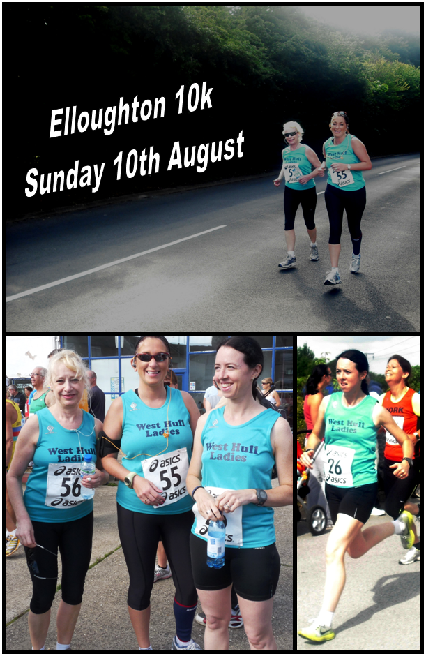

The big, big, BIG G....
Becca and Amanda

100 Mile Cycle Sportive
2,600M (8,530 ft) climbing

http://www.eastyorkshireclassic.co.uk/cyclosportive

The Big G: When Amanda asked me if I wanted to do the Big G cyclo-sportive with her, my immediate response was ‘yes’. Then I asked how far it was! I have done a few daft things with Amanda now and I always end up enjoying having a go and learning more about myself and what I can achieve when I push myself. Before doing this event I have never cycled more than 50 miles and had been cycling regularly for less than a year (with a big gap over winter as I don’t like getting wet on a bike).

Surprisingly, I easily persuaded Becca to partner me on this "adventure". It's quite a challenge for someone whose furthest cycle ever was 50 miles sometime last year. We booked in early May at which point neither of us had done much cycling this year (the broken wrist scuppered me). Becca's text after booking in summed it up "OMG - may the cycle gods help us".

Training: We did three long training rides together to suss out the route and have a go of the numerous hills - which ended up being a life saver on the day. It’s not just that the route we were doing was the longest of the three on offer, at 160km (or 98 miles). It was the amount of climbing that made it hard. After the first training session I realised the gearing on my bike just wasn’t set up for climbing and I was making things harder for myself. My bike was set up for racing on the flat and not doing steep climbs so I arranged a trip to the bike shop for it to have the gearing reduced to make things a bit easier for myself.

At the end of May I rode a steady, flat 60M cycle with the old men in the CTC group and struggled with my wrist. Becca with her Barracuda old men cycled a 50M route. We then started our training together. This consisted of 3 Saturday cycles in June (7th, 14th and 21st) when we took the "Map of Adventure" and on each cycle we rode some of the 11 hills of the BIG G. We met in Walkington. Each week was 10 miles further and our final cycle was 86M for Becca, 95M for me. The last one I struggled with and was grateful to sit on Becca's tail as she peddled into the head wind. The biggest memory of our training was plenty of bench stops with food and Millington Cafe which served enormous cakes with cups of tea.

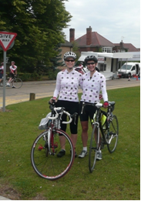
Pretty Jerseys Before the day I found some lovely jerseys on the internet at a very reasonable price so both Amanda and I bought one to wear on the day. We looked like a proper team in them.

The day came and I was feeling excited and a bit scared. I had made a cycle plan! I like to know where the food stops are and how far I will have to go before each stop. Throughout the long cycles I focus no further than the next stop. The cycle started at Longcroft School, Beverley. We were off early because we wanted to be back in time for the pie and chips and the kitchen closed at 5pm. We would have been gutted to miss that. So, 8am, photo shot and off.

The Start We got to the start early as we intended to be some of the first ones to set off to ensure we managed to get round before the cut off time of the food. If we have cycled all that way we wanted to have the free pie and chips at the end! The weather seemed OK. It wasn’t really hot as it had been previously and there was a mix of clouds and sun. It was a bit windier than we would have liked but having pedalled through some seriously strong winds on the training rides we weren’t too worried.

First stop top of Life Hill, 24M, 9:35am, 5 min break and consumed a yummy chocolaty sports bar. So far, a beautiful route through Etton, South Dalton, Middleton, North Dalton and a few other pretty villages then the long drag towards Huggate before heading down to Wetwang and the climb up Life Hill.

Next stop in 18 miles, the Feed Station above Thixendale. Now the climbs started in earnest and I felt guilty because my bike has the better gearing for hill climbing. For Becca it was tougher. This stage started with a long sweep downhill, then puffing up Fimber. Steep downhill, then up Burdale. A gorgeous valley and despite the steepness and long climb I enjoyed it.

Next down to Wharram Percy before heading to Birdsall and another long climb, though not quite so steep. Then, the beautiful descent into Thixendale before climbing Thixendale Brow. As I peddled up this one, plenty of people were weaving in front of me and a chap went so slow he simply fell sideways into the hedge! "Just resting" he said! Over the top and a mile to the food station. A cheese and onion wrap, large piece of flap jack, bottles filled, photo, then time for off. We now had 42 miles behind us and trying not to think about 58 miles still to go!

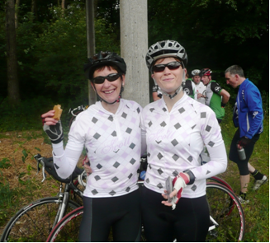
Eating at the top of Life Hill and at the Thixendale Feed Station
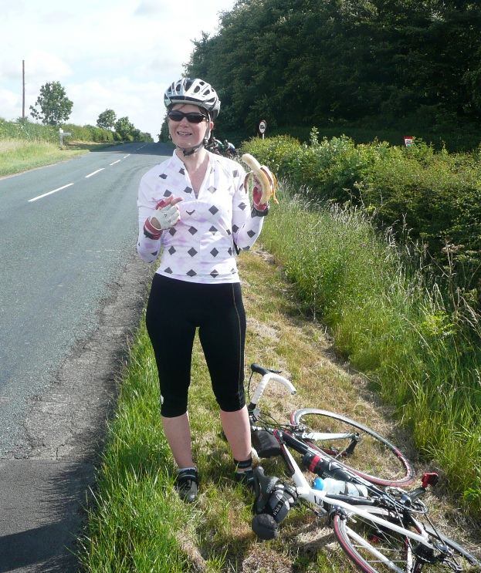
Hills! Amanda is a much better climber than I am and was soon ahead of me but waiting for me at the top of the hills. At about 40 miles I started to feel dreadful and started to doubt whether I would actually get round the course but after another food stop and something sugary to eat I started to pick up and was soon feeling better. Amanda was very organised and had planned our food stops at points throughout the day and we managed to keep to them fairly well. The weather was very changeable as we went round with the wind picking up a lot and making it hard pedalling into it and there was a mix of heavy rain downpours and light drizzle on and off throughout the day. Amanda and I were sensible and managed to stand under trees during the heaviest downpours – although we seemed to be the only cyclists who were employing this tactic!

Next stop was another 18 mile stretch, to Stamford Bridge. This time only 2 climbs ... but it did include the worst climbs of the cycle - "Hanging Grimston" (or as Becca calls it “Hanging on Grimly”) and the dreaded "Acklam" with its 1 in 5 gradient! As we headed towards Acklam my legs were feeling tired, which is scary when you are only half way round. I asked Becca how she was and was really concerned when she said “I am totally knackered”. I suggested a rethink at the top of Acklam and started considering the easiest route back. I needn’t have been concerned, Becca had no intention of jacking it in. So, onwards and downwards to Buttercambe before a flat road, with headwind, to Stamford Bridge. A couple of chaps passed and I immediately hooked onto them calling to Becca to “jump on”. They completely protected us from the headwind and their drag helped pull us along. Arriving in Stamford Bridge we thanked them and they offered to pull us along further, but it was time for another feed J.

The Hills While the hills were hard work and really slowed me down, I found that I wasn’t the only one suffering this and was often in good company - surrounded by blokes who were also struggling! I only got off and walked on one hill which I was quite pleased about. It’s Acklam which is a 20% climb and to this day I haven’t managed to pedal up it! (Amanda walked too).

Next stop was 16 miles to the second feed station in Huggate. It involved 2 more climbs but an easy section with backwind first. Just heading off ... revelation “Becca, stop ... your number is exactly double mine! Mine is 156 and yours is 312”! That had us giggling before cycling on.

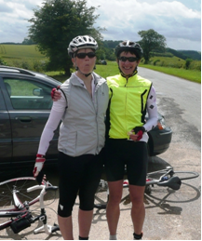
Just before Great Givendale climb the heavens opened and we sheltered under a tree and watched other cyclists peddling on through the rain. Rain cleared and up the hill, sorry to pass by Millington without our cafe stop. Onwards towards Millington woods, a gently rising valley to the last bit which was a killer but helped by kind words from the marshal as we popped over the top. Just a mile further to the second feed stop. 76 miles behind us and still going pretty strong.

Eating at Huggate Feed station.
Becca now part human, part hamster ☺

Final section broke down to 9 miles to the top of Nunburnham, followed by 14 easy miles. Spinning downhill to Warter, again stopped to shelter from heavy rain. A tough undulating road before heading to Nunburnham village and the last climb.

My legs raged at me when we set off up the hill but after about a minute gave up squealing and let me get on with it. Most way up a sign said “smile for the camera” ha, ha, ha! We both made it up and after a brief stop launched ourselves into the lovely long downhill to Market Weighton, picked up Kiplingcoates valley with a wonderfully strong back wind. Enjoyable as we knew we had cracked it. Back through Etton and Cherry Burton, legs feeling every rise but both of us happy to be turning the pedals with the end in sniffing distance.

Into Longcroft, through the timer, photo shot, bike computers reading 99.4miles .... very sad I know, we peddled round the car park to make it up to 100. Becca’s first ever century.

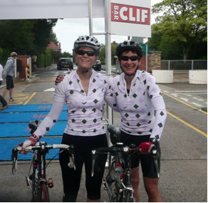

Off to the canteen for chips and stodgy steak pie, cake, cake and cake and cups of tea. Got the T Shirt, got the bright orange bike bottle and our first BIG G was done.

Pie and Chips Despite feeling awful initially I really enjoyed the day overall and it was lovely to cycle back into the finish to be greeted by Amanda’s family, including Rebecca, her son Matthew who had been marshalling, and Neil, her husband, who had cycled the same course but in a ridiculously fast time! And best of all we were in time for our pie and chips!
I would definitely be up for doing it again but I would be determined to cycle all the way up Acklam next time.

I sat on the grass outside later and a chap said to me “You girls were enjoying yourself weren’t you. You didn’t stop talking”. Is there any other way to spend a girls day out I wonder?


Racing and Running Events

Event | Distance | Date | Where | Entry Fee
Burton Pidsea 10K  AND Fun Run  BUPA GREAT NORTH RUN  (www.greatrun.org)  Cusworth 10K  AND Fun Run  Sutton Park 10K | 6.2 miles  1 mile  13.1 miles  6.2 miles  1 mile  6.2 miles | Sunday 12th September  Sunday 19th September  Sunday 26th September  Sunday 26th September | Memorial Hall @ 11.15am  @ 10.15am  Newcastle @ 10.40am  Doncaster @ 11am  @10.15am  Sutton on the Forest @ 12pm | Member: £9  Unattached: £11  Fun Run: £2.50  Charity places available  Member: £10  Unattached: £12  Fun Run: £3  Member: £8  Unattached: £10
Maplethorpe Marathon  Maplethorpe Half  Bridlington Half  AND Fun Run  Haltemprice 10K  Yorkshire Coast 10K Road Race and Family Fun Run | 26.2 miles  13.1 miles  13.1 miles  1 mile  6.2 miles  6.2 miles  1.5 mies | Sunday 3rd October  Sunday 17th October  Sunday 24th October  Sunday 31st October | Maplethorpe @ 9.30am  Maplethorpe @ 10am  Bridlington Seafront @ 12pm  @ 11.15am  Wolfreton Upper School  @ 11am  South Bay, Scarborough  @ 10am and 11.30am | Member: £10  Unattached: £12  Member: £10  Unattached: £12  Member: £8  Unattached: £10  Fun Run: £2  Member: £6  Unattached: £8  Member: £11.50  Unattached:£13.50  Fun Run: £3
** Dates/times are subject to change **

If you want any further information about these races, races out of this region or know of any races not mentioned above please get in touch via West Hull Ladies e-mail and mark your e-mails for the attention of ‘Karen S’. I have also added local fun runs for everyone especially with those who have children who would like to have a go!

Please keep checking the race page on the website as I’m adding races as they arrive in my inbox. Also Race Results are replacing the Entry Forms as they become available.

Please let me know if you are entering races as it may give others that little bit of encouragement to get signed up.
Give training purpose…sign up for a race, train regular with the club and this will help you to stay motivated as a West Hull Ladies runner.

Karen S, Racing Officer

NOTE: Club Vests must be worn at any races you enter
under the West Hull Ladies running club name.

CLUBWEAR PRICES:
Vest | £15.00 | All items are ordered on request and must  be paid for at time of ordering. To place  an order please get in touch via West  Hull Ladies e-mail and mark your  emails for the attention of Geri.
T- shirt | £16.50
Hoodie | £14.00
Jacket | £32
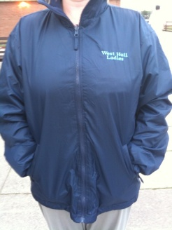
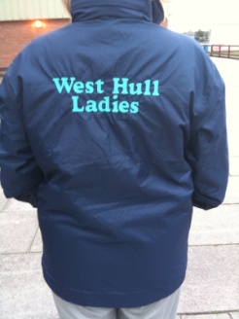
New Club Jacket available in three sizes: small, extra small, and junior (large fitting). If you would like to purchase one please send a cheque for £32 to Victoria Voase, Treasurer, and state on the back of your cheque your name and that the cheque is for a jacket.

Becca

Running Library

Using the library - Locker 18.
Choose your book, write your name and date on the card and leave the card in the locker so we know where the book is.
Book List:
- The Runner's Diet (Runners World), Madelyn H. Fernstrom
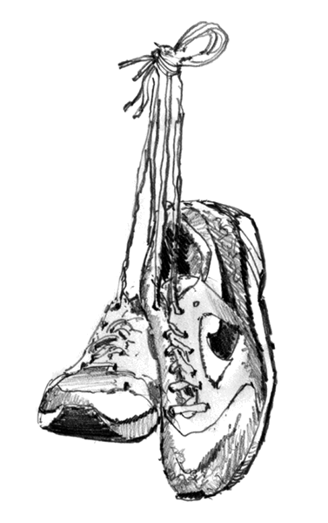
- Paula My Story So Far, Paula Radcliffe
- Running Made Easy, Susie Whalley
- The Complete Book of Running for Women, Claire Kowalchik
- Absolute Beginner's Guide to Half Marathon Training, Heather Hedrick
- Run Fast: How To Beat Your Best Times Every Time, Hal Higdon
- The Runner's Handbook, Bob Glover
- The Competitive Runner's Handbook, Bob Glover & Shelly Lynn Glover
- Marathon: From Start To Finish, Sam Murphy
- Marathon Running For Mortals, John Bingham
- Four Months to a Four-Hour Marathon, Dave Kuehls
- Marathon Running Beginner to Elite, Richard Nerurka

Running Magazines: These are available to borrow from the table in the club room.

